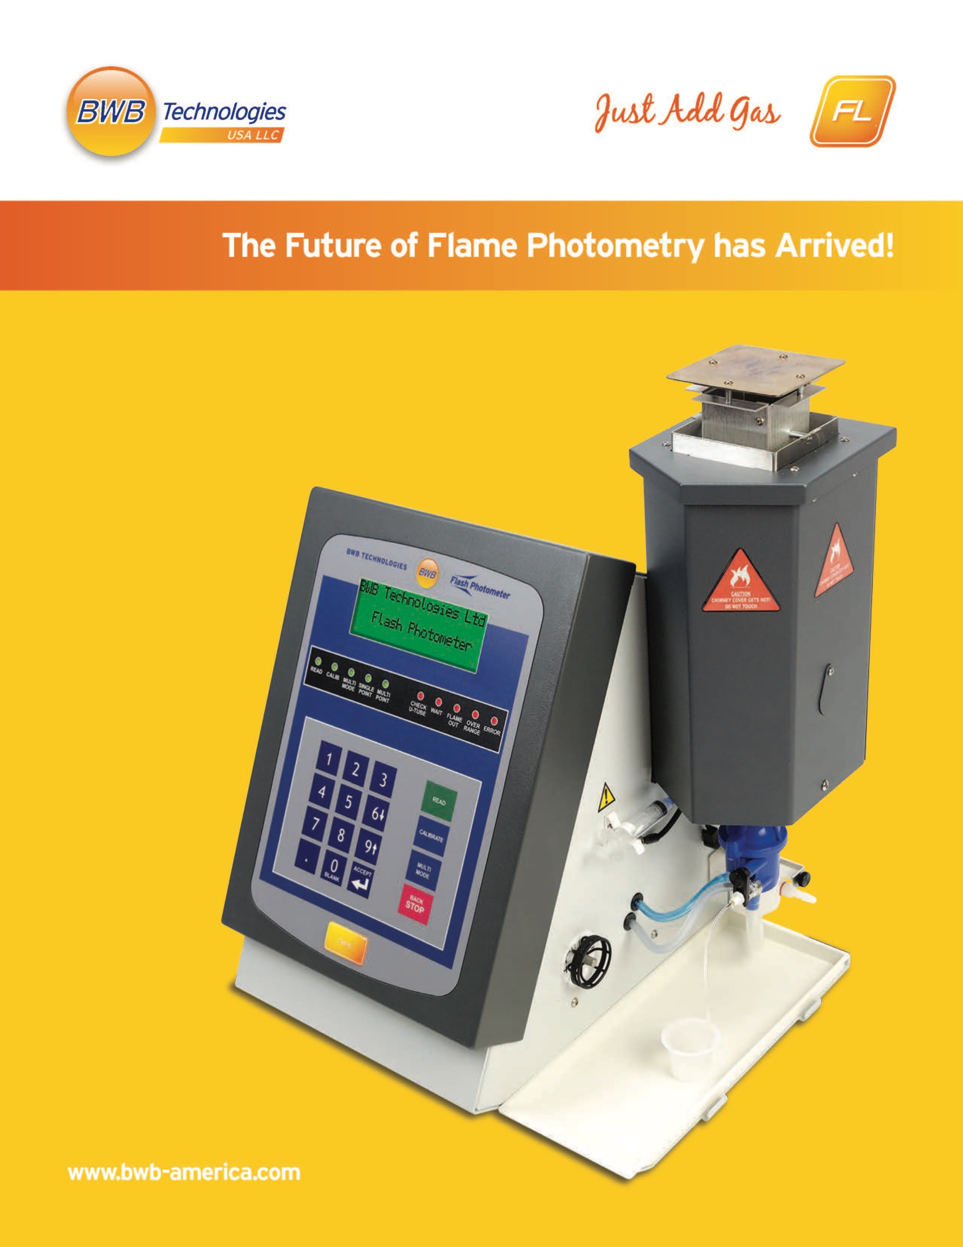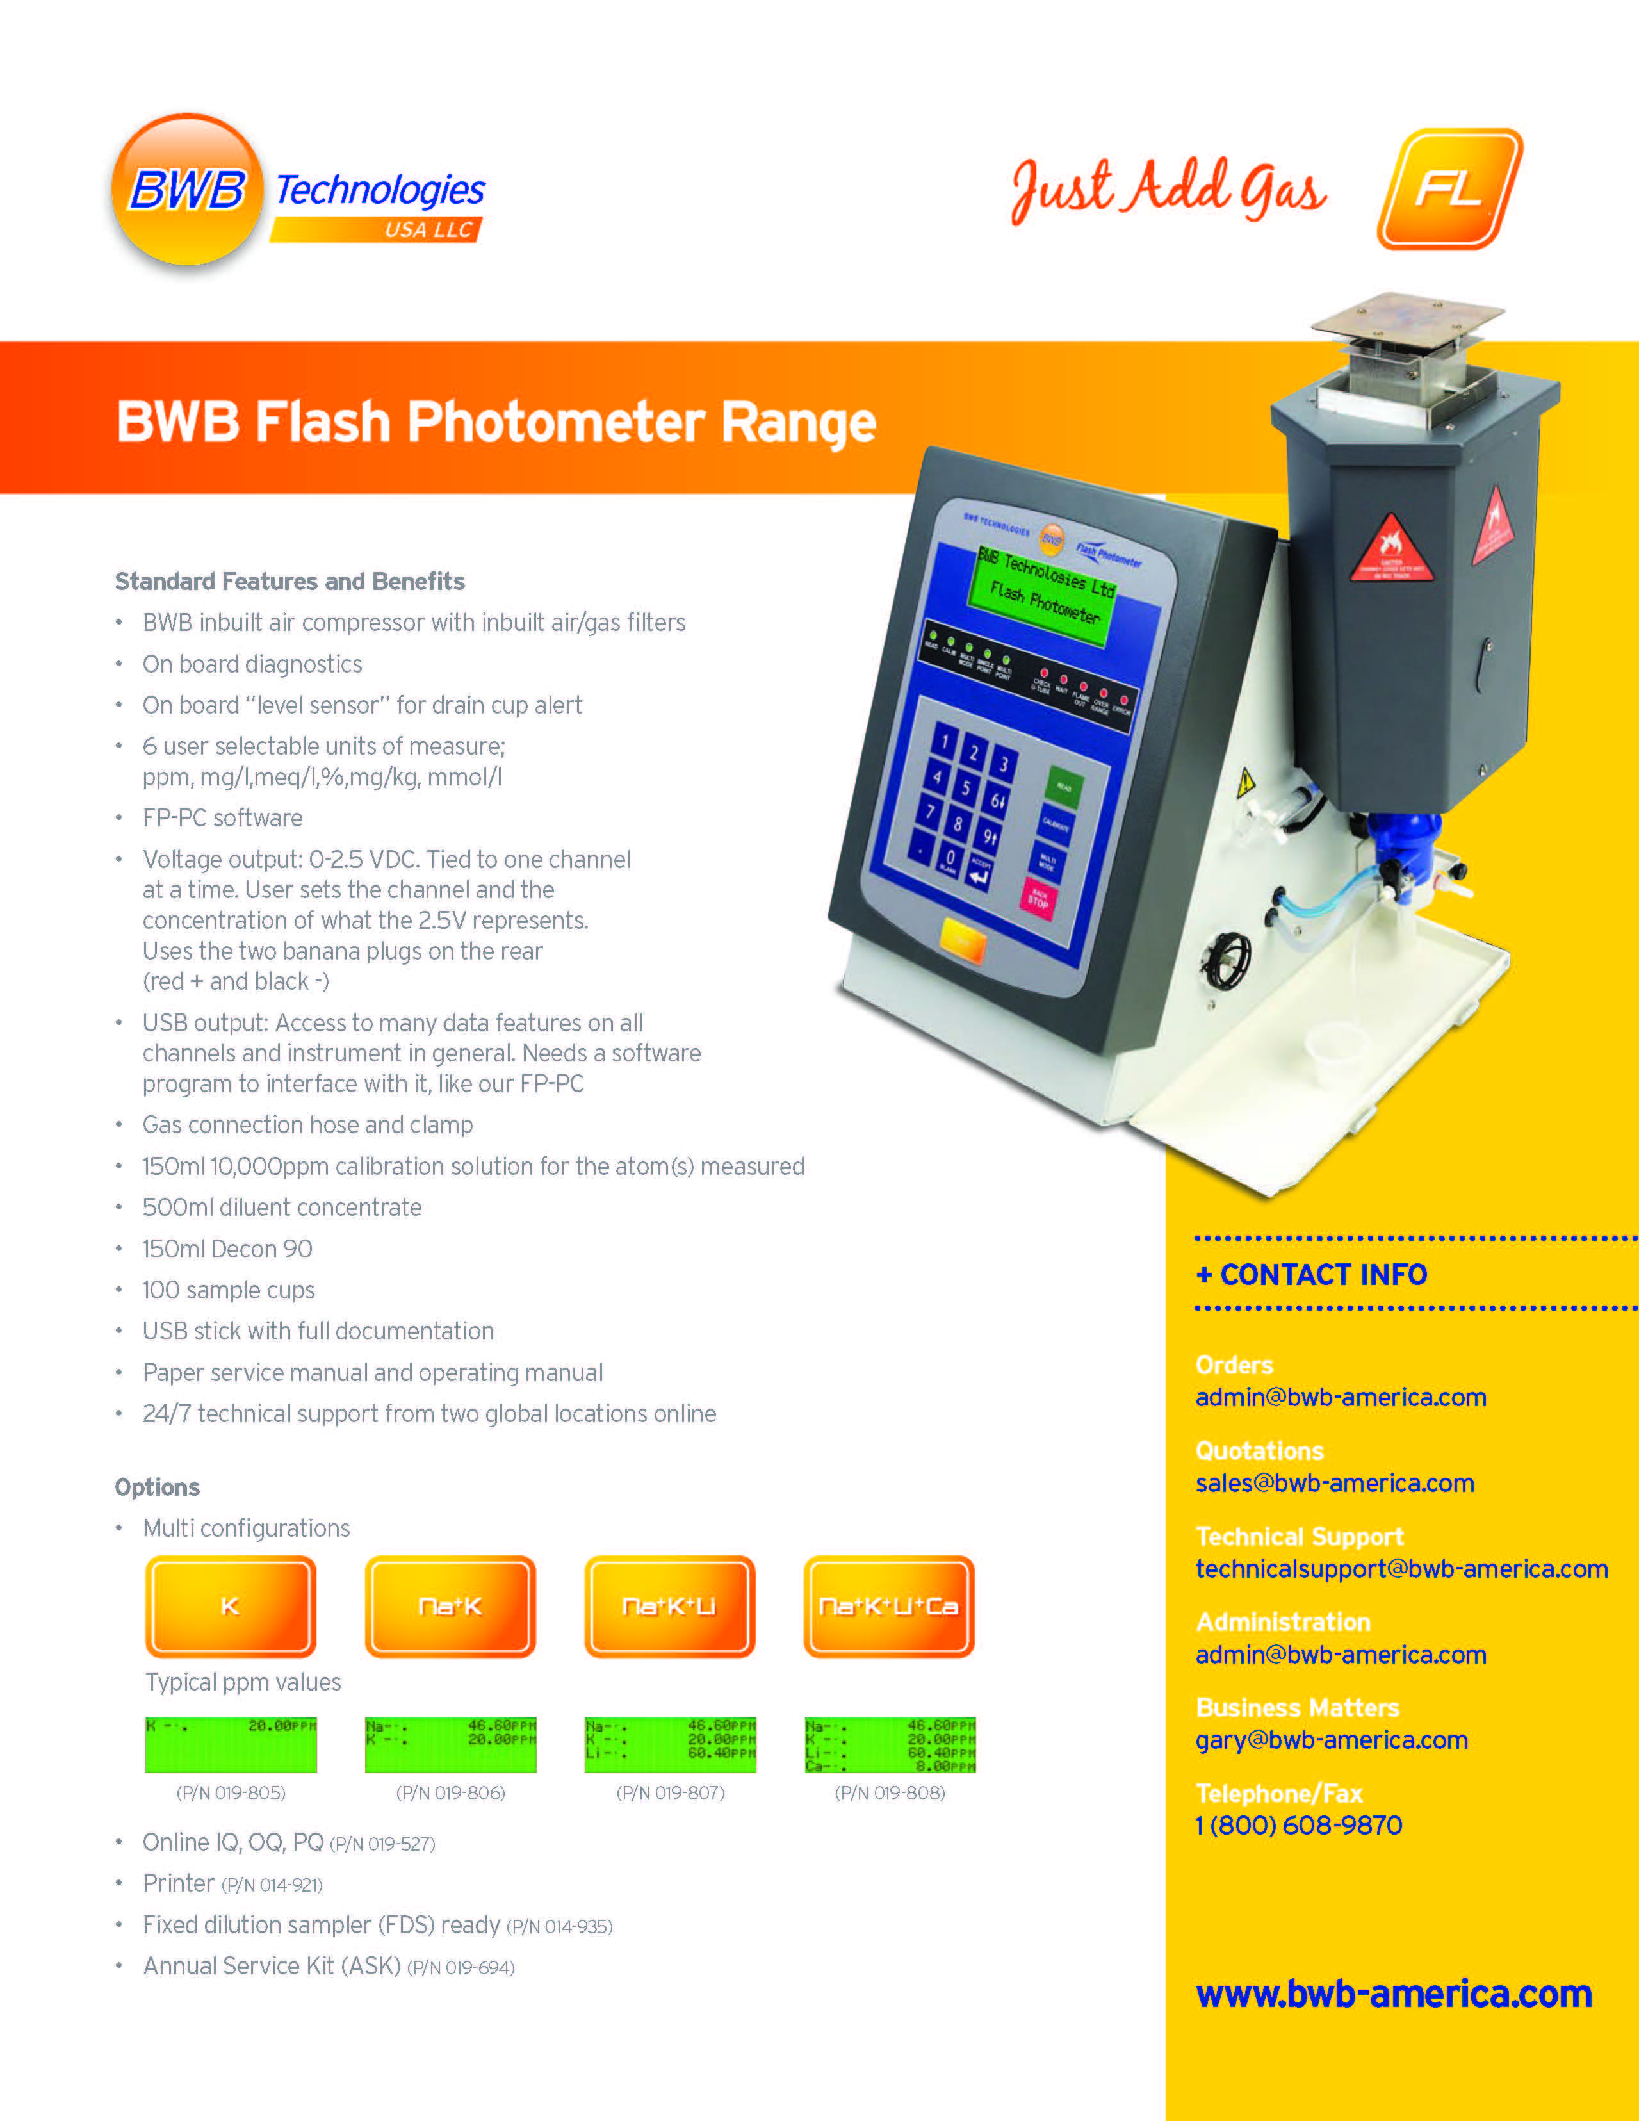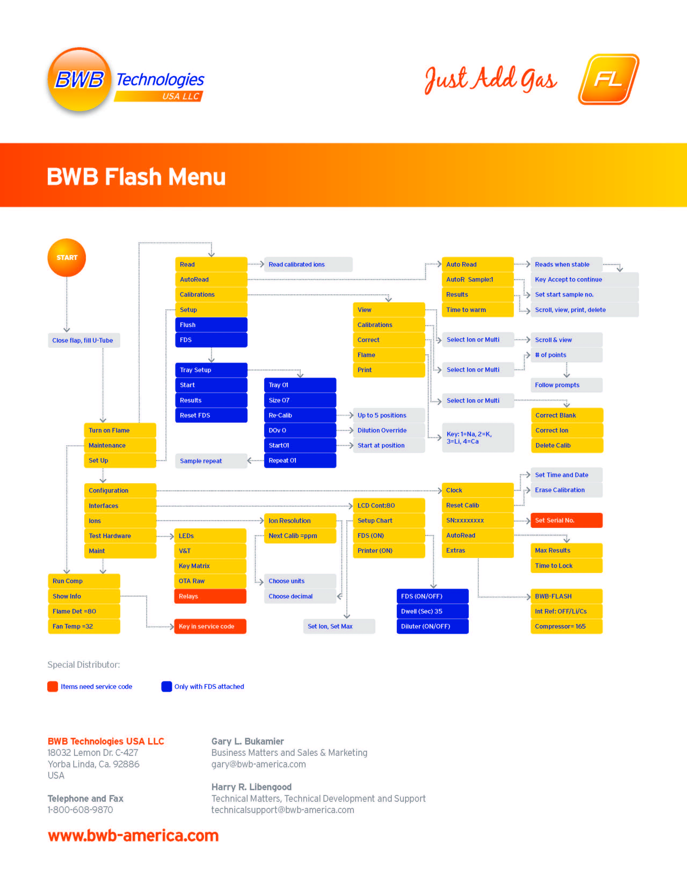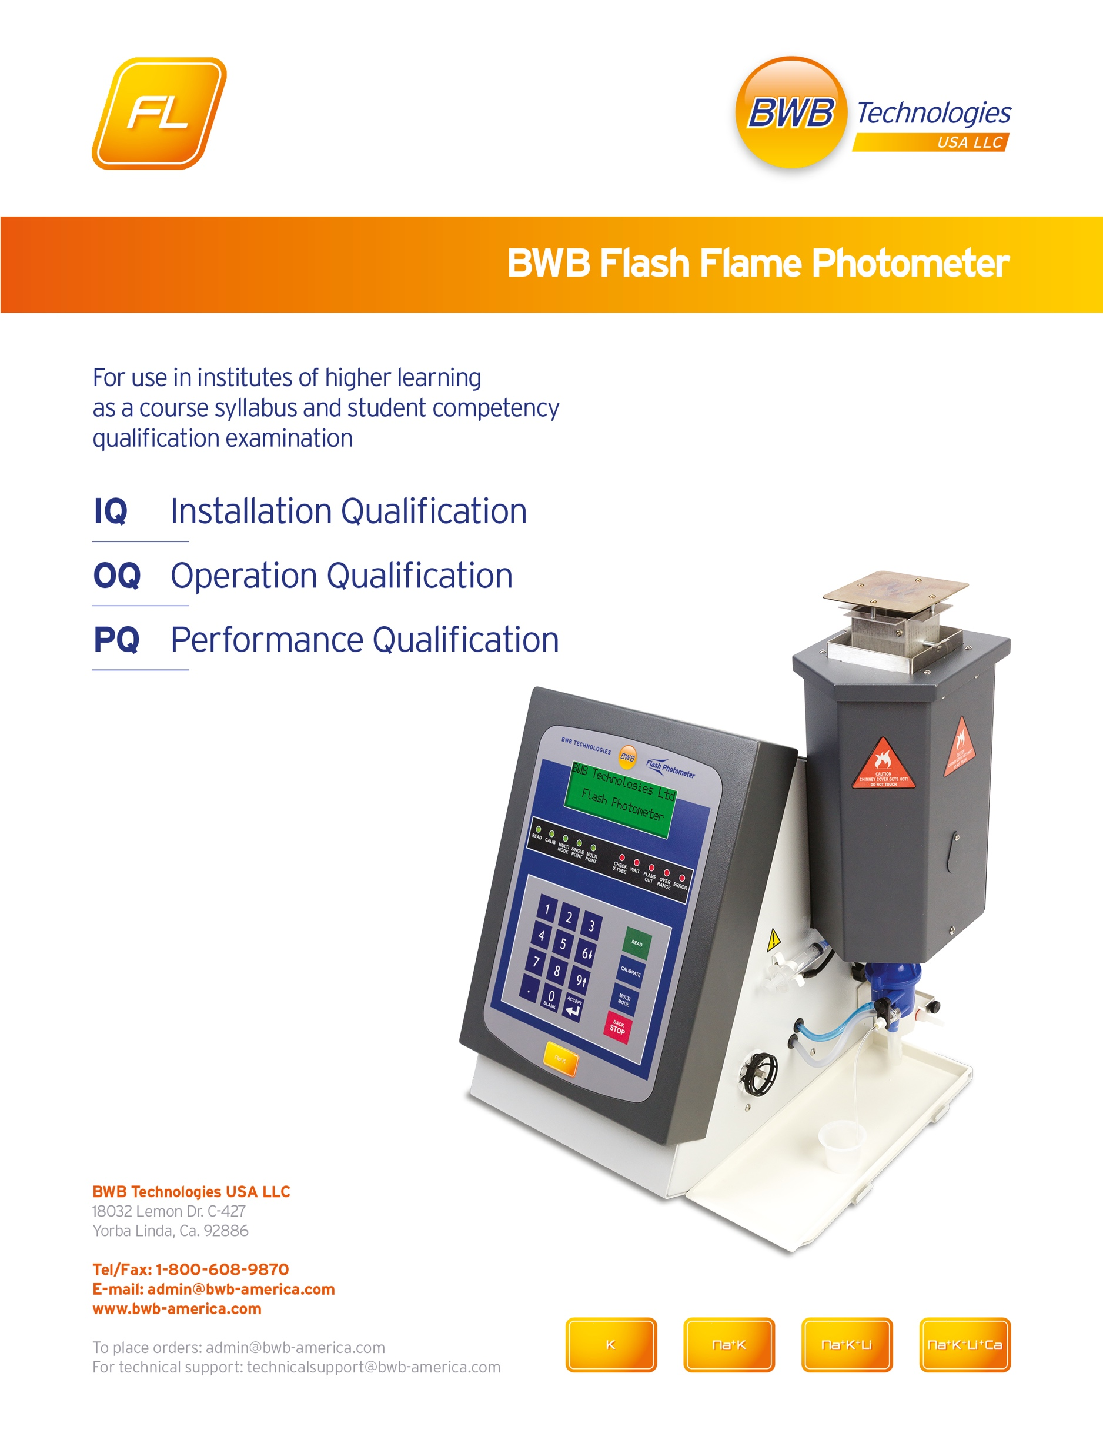
CONTENTS

Installation Qualification – IQ

Installation Qualification establishes that the instrument is received as designed and specified, that is properly installed in the selected environment, and that this environment is suitable for the operation and use of the instrument.

SECTION 1
Contract 8
Equipment Checklist 8-9
Document Checklist 9
Packing List 10
Purchase Order 11
Installation Checklist 12

SECTION 2
Service, Maintenance and Repair Schedule 12

SECTION 3
Firmware 13

SECTION 4
Consumables 13

SECTION 5
Site Requirements, Installation, Environment and Services 14-15

SECTION 6
Health and Safety 16

SECTION 7
Instrument Functionality at Power Up 16

SECTION 8
Completed Installation Qualification and Declaration IQ 17

Operational Qualification – OQ

Operational Qualification establishes that the instrument is received operating and functioning as described in the product specification. The Operational Qualification also ensures the peripherals are working as intended and specified.

SECTION 9
Functional/Diagnostic Checks 18
Operation with Accessories 19
Completed Operational Qualification and Declaration OQ 20

SECTION 10
Addendum A: Installation and Operating Manual 22
Addendum B: Calibration Certificate 23
Addendum C: CE Certificate 24

Performance Qualification – PQ

The Performance Qualification ensures the user has correctly set up and run the BWB Flame Photometer using any additional peripherals. The results acquired from the running of this test allow BWB Technologies to issue a Performance Qualification Certificate.

SECTION 11
Test Protocols without the optional AFHS* 25-26
Test Protocols with the optional AFHS* 26-27
Test Results 28
Addendum D: Certificate of Conformance PQ 29

*AFHS (Automatic Fluid Handling System)

Installation Qualification - IQ

Installation Qualification establishes that the instrument is received as specified, that is properly installed in the selected environment and that this environment is suitable for the operation and use of the instrument.

Section 1 - Contract

This Section contains copies of the following documents:

- Contract
- Revisions to Contract
- Additional Comments and/or Specifications
- Packing Slip
- Installation Checklist

Section 1 - Equipment Checklist

When unpacking the instrument it is recommended that all items contained within the main shipping carton and accessory boxes are checked off using the Unpacking List.
Any shortages or damage should be reported immediately to your local agent or BWB.

Checklist | Carton/Goods Undamaged | All Items Ordered Present
Outer Carton

Inner Accessory Cartons – including all accessory items listed on the Unpacking List
Starter Pack contents

Any additional Accessory/Spares items requested at time of ordering the product
Delivery Note/Packing Slip was checked with the contract and was considered complete

I hereby declare that I have checked all the above items and certify that they are in order.
Date | Signature | Print Name | Title

I have examined all of the above, but have found that the following items are deficient:

Item No. | Deficiency Detail

Date | Signature | Print Name | Title

Section 1 - Document Checklist

Document Description | Version Number | Date of Publication | Number of Pages
BWB Installation and Operation Manual
Quick Start Guide
Warranty Statement
Registration Form
Calibration Standards MSDS (Material Safety Data Sheets)
Certificates of Analysis
Unpacking List
Printer Manual - optional
AFHS Manual - optional
Service Guide - optional

I hereby confirm that the above documents were delivered.

I have attached a copy of each document to Addendum B

Date | Signature | Print Name | Title

Section 1 – Packing List (attach a copy here)

Section 1 – Purchase Order (attach a copy here)

Section 1 - Installation Checklist

The following checklist is meant for in-house installation. This additional information is useful for the recordings of the results for GLP (Good Laboratory Practice).

Instrument Model :
Serial Number:
Installation Date:
Installation Site:
Service Interval:
Calibration Interval:

BWB Technologies recommends a maximum service interval of 12 months.

Accessories Checklist | Model Number | Serial Number

Section 2 - Service, Maintenance and Repair Schedule

The service intervals recommended by the manufacturer are only a guideline. Only a recommendation is given, since the frequency of necessary maintenance intervals depend on the environment and on the use and care of the equipment. The user should enter the service intervals accordingly. Details of Routine Maintenance are specified in Section 7 of the Installation and Operation Manual.

Item | Recommendation from Manufacturer | User defined Intervals | 1st Service or  Calibration due on:
Routine Service | Refer BWB Manual

Section 3 - Firmware

The internal Firmware of the equipment was examined and evaluated in compliance with the guidelines of the manufacturer. To see the firmware version; Go to Maintenance > Show Info.

Instrument Firmware Version No.

Section 4 - Consumables

Required Consumable Material:

Consumable | Part Number | Qty Received
Sample cups (100) | 019-045

Calibration standards:
Na: 10,000ppm, 150ml Standard | 019-010
K*: model dependent | 019-011
Li**: model dependent | 019-012
Ca***: model dependent | 019-013
Decon® 90 cleaning agent | 019-050
Diluent Concentrate | 019-015
Deionised water | 019-051

Section 5 – Site Requirements, Installation, Environment and Services

Installation site of the Instrument

The installation site of the instrument must be selected in such a way that the function of the equipment is not impaired and for the fulfilment of the manufacturer’s recommendations.
The installation site is confirmed as follows:

Installation Requirement: | Tick to Confirm
Is the environment clean, free of dust and airborne contaminants?
Is the volume and ventilation sufficient to prevent build-up of combustion products?
Will the environment be maintained within a range of +10 to +35˚C?
Will the environment be maintained at less than 85% RH (non-condensing)?
Is the site free from draughts and away from air conditioning units?
Is the instrument shielded from direct sunlight and other intense light sources?
Is the worktop sufficiently stable and robust to safely bear weight of the instrument?
Is there space of at least 50cm deep and 60cm wide available on the worktop?
Is the instrument sited so that it does not impede other activities within the area?
Is there at least 1 metre of clear space above the instrument chimney?
Is a 100-250V, 50/60Hz electrical supply (2A minimum) available and connected?
Is the instrument fitted with the correct gas regulator for the intended gas supply?
Is a gas supply (Propane, Butane or Natural Gas) available and connected?
If Natural Gas is being used, has a certified installer performed the installation?
Does the storage and supply of gas comply with all recommendations and regulations?
Have all gas connections been checked and confirmed to be leak free?
Is a sink or other suitable container available for disposal of waste overflow?
Is the drain tube clear to run to drain and the end maintained above the liquid level?
If an external air source is being used, is this regulated to 0.20-0.34 bar?
If an external air source is being used, is this free from oil, and airborne contaminants?
If an external air source is being used, has it been connected and confirmed leak free?

I confirm hereby that the place of installation is suitable for the instrument so that there:
- Is sufficient space for the installation and the operation of the instrument
- That the site of installation complies at this time with the general conditions for the start-up of the equipment, as recommended in the operating instructions.

Date | Signature | Print Name | Title

Comments about the Installation Site:

Environment and Services

Electricity and electrical requirements of the instrument.

For these requirements, please refer to the technical description in the operating instructions.

Description of the available electrical services:

Section 6 - Health and Safety

The equipment is marked with the CE Mark and meets:
- The regulations for the European Electromagnetic Compatibility 2004/108/EC.
- The European Low Voltage Directive 2006/95/EC.

A CE-conformity declaration with the appropriate details is contained in Addendum D.

The following declaration must be signed by the authorized person performing this Qualification.

I declare that I have read the operating manual and that I am familiar with the functionality of the Instrument.

Date | Signature | Print Name | Title

Section 7 – Instrument Functionality at Power Up

Instrument Description | Pass | Fail
BWB Flame Photometer
BWB AFHS Auto-Sampler / Auto-Diluter

I have checked the instrument functionality at power up and confirm it is satisfactory.

Date | Signature | Print Name | Title

Section 8 - Completed Installation Qualification and Declaration - IQ

IQ – This section was fully checked by: |  | Initials
Name:

Title:

Company Representative:

Observations:

Required Corrections: | Details of the corrections, agreed completion dates and individuals responsible: | By Date
Corrections Completed: | Indicate how each correction has been completed. | Date and Initial

Date | Signature | Print Name | Title

Section 9 - Operational Qualification - OQ

Operational Qualification establishes that the instrument is received operating and functioning as described in the product specification. The Operational Qualification also ensures the peripherals are working as intended and specified.

Section 9 - Functional / Diagnostic Tests of the instrument

For diagnostic tests select: Setup->Hardware Test from the Main Menu.

Operation Checklist | Pass | Fail | Comments
LED Test (all LED’s cycle on/off in turn)
Voltages & Temperatures (results below)
Key Pad Matrix (all keys detected)
OTA Raw Readings (variable low values)
Main Menu - Flame ignites. Flame detected

Voltages and Temperatures | Value Displayed | Pass/Fail  (± 10%)
+ 5 V
+ 12 V
+ 24 V
OTA Temp
CPU Temp

The above test results were obtained according to the operating instructions:

Date Checked | Checked By | Title/Department

Section 9 - Operation with Accessories:

Details of the tested accessories

Description | Model Number | Serial Number
BWB AFHS Auto Sampler and Diluter

BWB Printer | N/A | N/A

AFHS Test:

The following tests are performed at Setup > Test Hardware > AFHS. The AFHS should be turned ON.

Function | Pass | Fail | Comments
Initialise
GOTO (any position)
Flush (did diluter work?)
Park

Printer Test:

Perform at; Turn on Flame > Serum > Na/K > Calibrations > Print.

I confirm the Printer functioned correctly during the test.

Date | Signature | Print Name | Title

Additional comment for the operation:

Section 9 - Completed Operational Qualification and Declaration - OQ

OQ – This section was fully checked by: |  | Initials
Name:

Title:

Company Representative:

Observations:

Required Corrections: | Details of the corrections, agreed completion dates and individuals responsible: | By Date
Corrections Completed: | Indicate how each correction has been completed. | Date and Initial

Date | Signature | Print Name | Title

Section 10 – Addendums A, B and C

I have attached the following documents in this Section:

Addendum A
Operating Instructions (Provided with the Flame Photometer)

Addendum B
Calibration Certificate (if available)

Addendum C
CE Certificate (Provided both with this document and the Flame Photometer)

Date | Signature | Print Name | Title

Addendum A

Operation Manual

A copy of the operating instructions is attached, or is filed under:

______________________________________________________________________

Quick Start Guide

A copy of the Quick Start Guide is attached, or is filed under:

______________________________________________________________________

Warranty Statement

A copy of the Warranty Statement has been returned to BWB Technologies and is attached, or is filed under:

______________________________________________________________________

Registration Form

A copy of the Registration Form has been returned to BWB Technologies and is attached, or is filed under:

______________________________________________________________________

Calibration Standards MSDS and Certificates of Analysis

A copy of the MSDS and Certificates of Analysis are attached, or are filed under:

______________________________________________________________________

Service Guide- Optional

A copy of the Service Guide is attached, or is filed under:

______________________________________________________________________

Addendum B

Calibration Certificate
(Circle the following as appropriate)

- There is no calibration certificate for the installation

- The following calibration certificates are attached to this addendum:

Document Description | Issue Number | Date Of Issue

Addendum C – EC Declaration of Conformity

Section 11 - Performance Qualification - PQ

Performance Qualification establishes that the instrument, once properly installed according to the IQ-Installation Qualification and operated according to the OQ-Operation Qualification, will perform to the original factory specifications.

Instrument Model:
Serial Number:
Date of Testing:

I. Testing Protocol without optional AFHS: Use the following protocol to gather the requisite data. Ensure that all containers and volumetric ware are clean and rinsed with good quality de-ionised water and fully dried where appropriate.

A. Test Solutions
1. Diluent/Blank. In a plastic one litre volumetric flask, add 1ml Diluent Concentrate and bring to volume with deionised water. This solution will be used both as the Blank and to make the Test/Calibration Standard.

Date | Signature | Print Name | Title

2. Test/Calibration Standard. In a supplied 100ml volumetric flask add the following and bring to volume with Diluent/Blank Solution from above. This will be used for calibrating and testing. Note; this solution must be used the same day it is made.

a. 0.2ml of 10,000ppm Na Standard. Final concentration = 20ppm.
b. 0.2ml of 10,000ppm K Standard. Final concentration = 20ppm.
c. 0.2ml of 10,000ppm Li Standard. Final concentration = 20ppm.
d. 0.2ml of 10,000ppm Ca Standard. Final concentration = 20ppm.

Date | Signature | Print Name | Title

B. Instrument Set-Up and Calibration
1. Start the instrument and warm up for at least one hour while aspirating the Blank made above. Observe the flame and set the height of the small cones at 8-10mm above the burner surface. Wait for five minutes.

2. In the Set Up menu, Ions, Ion Resolution set the maximum decimal point for all ions to 1.

Date | Signature | Print Name | Title

3. Perform a Single Point Calibration on all ions using the Blank from I.A.1. above and the individual ion concentrations from I.A.2.a.-e. above.

Date | Signature | Print Name | Title

C. Perform the Test
Within five minutes of the calibration run alternately between the Blank (I.A.1.) and the Calibration Standard (I.A.2.). Enter the stabilized readings into the table below. If the optional Printer is installed a print out can be substituted.

Na |  | K |  | Li |  | Ca
Blank | Test | Blank | Test | Blank | Test | Blank | Test

Date | Signature | Print Name | Title

Certification: Make a copy of this Performance Qualification document and email it, with the print out if opted, to techicalsupport@bwb-america.com . After review and acceptance a Certificate of Conformance will be sent back.

II. Testing Protocol with optional AFHS: Use the following protocol to gather the requisite data. Ensure that all containers and volumetric ware are clean and rinsed with good quality de-ionised water and fully dried where appropriate.

A. Test Solutions
1. Diluent/Blank. In a plastic one litre volumetric flask, add 1ml Diluent Concentrate and bring to volume with deionised water. This solution will be used both as the Diluent and the Blank during the calibration step.

Date | Signature | Print Name | Title

2. Test/Calibration Standards. In the supplied 100ml volumetric flask add the following and bring to volume with Diluent/Blank Solution from above. This will be used for calibrating and testing.

a. 10ml of 10,000ppm Na Standard. Final concentration = 1000ppm.
b. 10ml of 10,000ppm K Standard. Final concentration = 1000ppm.
c. 10ml of 10,000ppm Li Standard. Final concentration = 1000ppm.
d. 10ml of 10,000ppm Ca Standard. Final concentration = 1000ppm.

Date | Signature | Print Name | Title

B. Instrument Set Up and Calibration
1. Start the instrument and warm up for at least one hour while aspirating the Blank made above (II.A.1) according the the AFHS operating instructions. Observe the flame and set the height of the small cones at 8-10mm above the burner surface. Wait for five minutes.

2. Set up the instrument and AFHS;
a. Next calibration units = ppm.
b. Ion resolution = 1 decimal.
c. Dilution ratio = 1:100.
d. Set up either, or both:
i. The Printer to print.
ii. The FP-PC software program ReportTab set to generate a .csv report.

3. Calibration; Fill 10 each of the supplied 5ml vials with at least 1ml of the calibration solution from II.A.2 above. Fill the large pot on the left side of the auto sampler with DI water and the Diluter Reservoir with the diluent from II.A.1 above. Do a single point automatic calibration (use service code 1267988).
a. Take one of the vials and place in position 1 of the auto sampler.
b. When prompted, enter the calibration concentrations for Na, K, Li and Ca as 10ppm. Enter Ba as 30ppm.
c. Run the calibration.

Date | Signature | Print Name | Title

C. Perform the Testing
a. Place all 10 vials in positions 1-10.
b. Designate position 1 as a re-cal.
c. Initiate the testing.

Date | Signature | Print Name | Title
Certification: Make a copy of this Performance Qualification document and email it with the print out and/or the .csv file, to techicalsupport@bwb-america.com. After review and acceptance a Certificate of Conformance will be sent back.

Attach a copy of the Printed Results here:

I confirm this is a true and accurate report of the results gathered using the sample vials provided.

Date | Signature | Print Name | Title
Certification: Make a copy of this Performance Qualification document and email to techicalsupport@bwb-america.com. After review and acceptance a Certificate of Conformance will be supplied.
Addendum D – (Attach Certificate of Conformance here)

